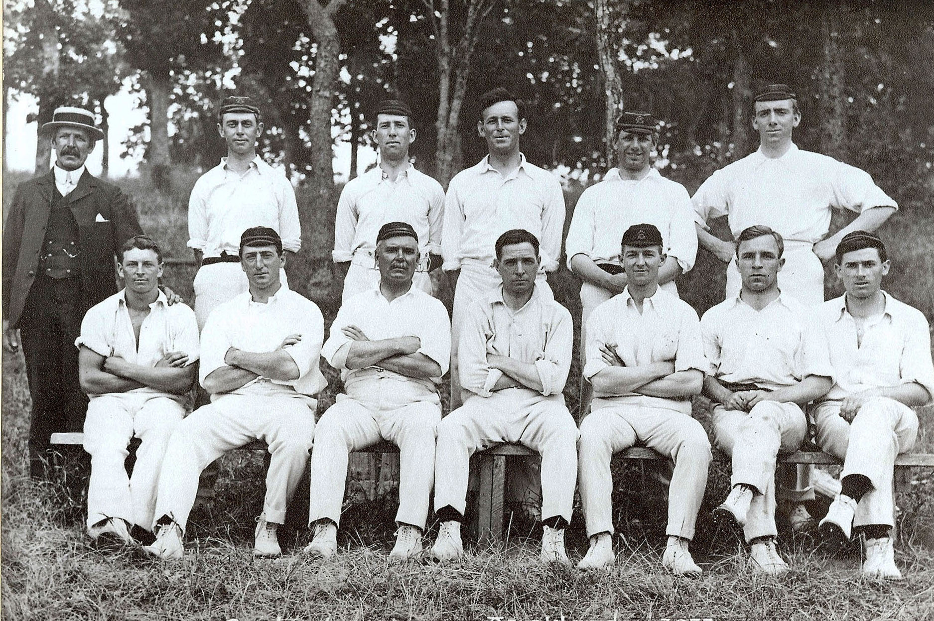

**Canterbury versus Auckland 28 January 1911 Auckland Domain**

**Back row:** JN Fowke (selector), HB Lusk, ER Caygill, JH Bennett, A Sims, T Carleton

**Front row:** DM Sandman, W Carleton, C Boxshall, D Reese (captain), WR Patrick, EE Crawshaw, AD Norman